- CUSTOM ORDER CREATION:

The custom order module works with it's own commission percentage setting. The admin can set this in the admin panel.
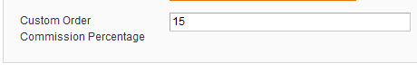

The seller menu will have a new link to the "My Custom Orders" page.
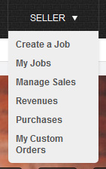

The "My Custom Orders" page lists all the seller's created custom orders and has a link to create a new custom order.
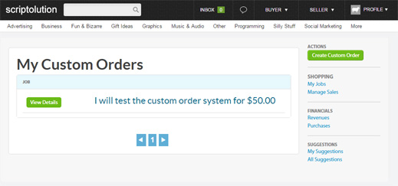

The create custom order page lets you enter the title, price, description and days to completion.
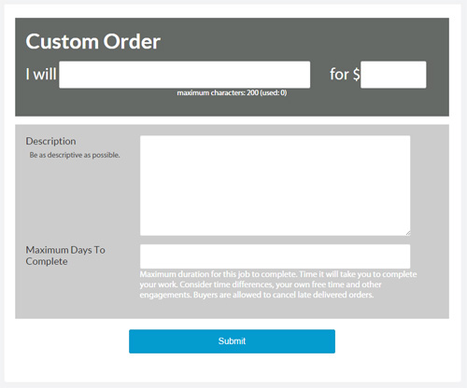

After you create the custom order the success page will show you the link to it as well as let you send the custom order as a conversation message to any user you have an existing conversation with.
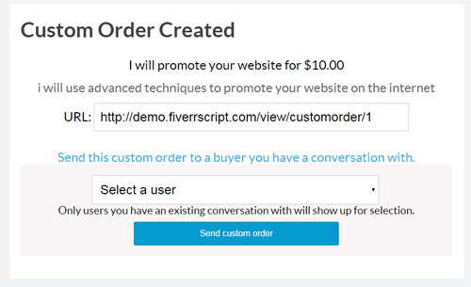

If the seller sends it to the buyer, they will get a message with a link to it.
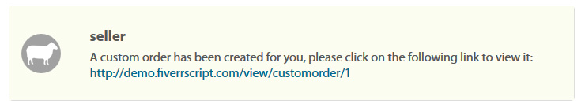

The view custom order page has a summary of the order and a link to pay for it.
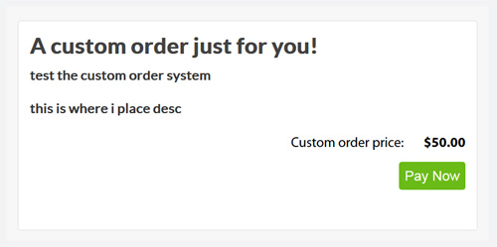

The buyer will then be taken to the payment page as they would be for any other order.

Everything else then proceeds as any other order would.

2. POST A REQUEST

Buyers can post a request, which includes a description, category, budget and delivery days.
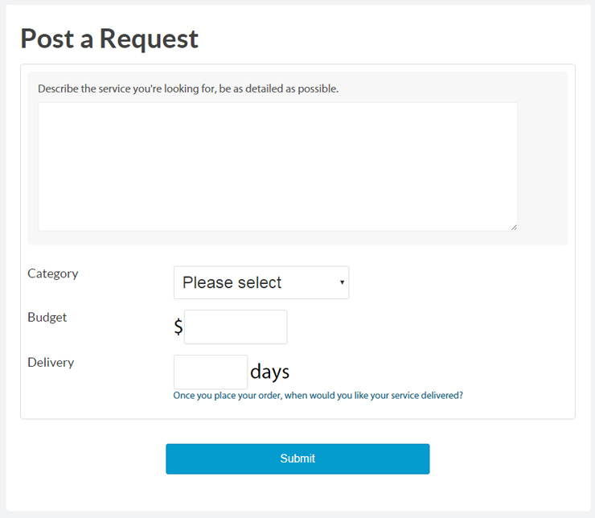

Requests can be managed by the buyer in their account.
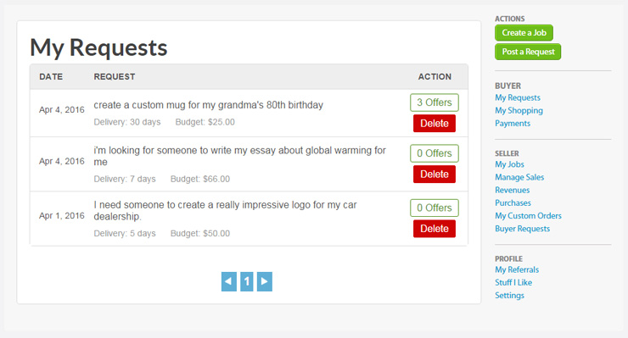

Requests page lists all active buyer requests for sellers to view.
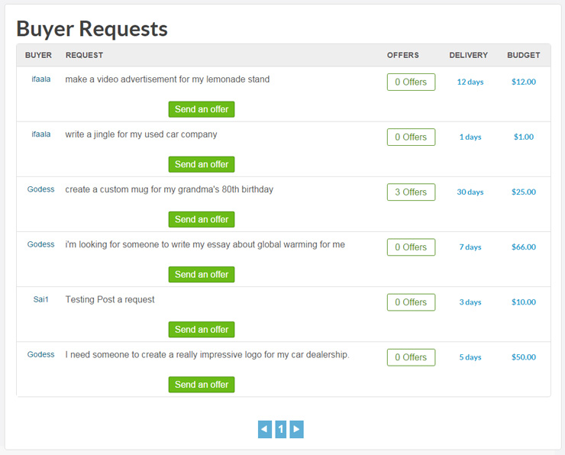

Sellers can send offers to buyer requests.
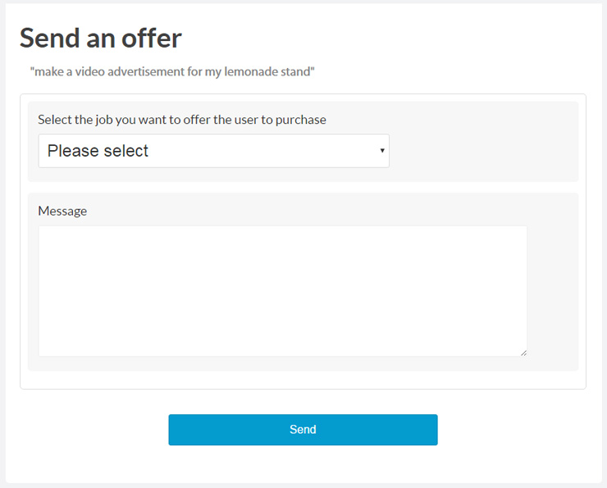

*E-mail Notification* - If the buyer's e-mail address is verified, they will receive an e-mail notification when a new offer is sent to them.

Buyers can view any offers sent to them.
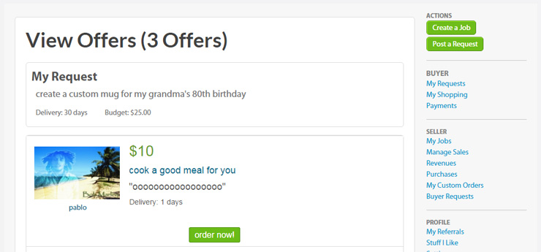

We also added the 5 most recent requests to the homepage, along with a link to view all requests.
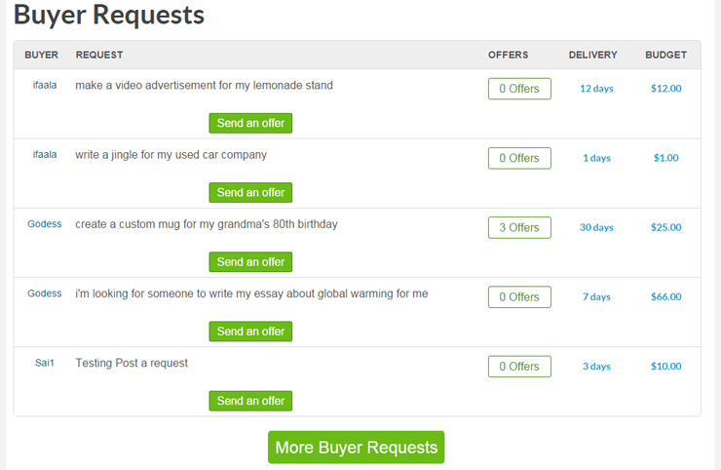

***** EMAIL NOTIFICATIONS FOR BUYER’S REQUEST AND IN RETURN SELLERS OFFERS EMAIL NOTIFICATIONS SENT TO THEM ONLY IF THEY PURCHASE MEMBERSHIP PLAN. OTHERWISE THEY CANT GET EMAIL NOTIFICATION****
3.MEMBERSHIP PLAN: (BYPASS PLAN)
This plan is mainly for sellers who cant get commission deduction for their work. So they can bypass their service by sending a request. So, once buyer request, there is no ordering for that project. So no commission deduction. No dispute raising. Because its all their responsible. But only one buyer can do. They can review and rate seller. Those who are buying this plan they get benefits too.
Bypass Plan details:
- Able to send request to buyer for bypass their service (means pay directly to the seller with no payment commission deduction)
- Featured advertising free for2 days (No. of days set in admin panel)
- E-mail notifications for both buyer and seller (Only for Buyers request to sellers and sellers offers to buyers). Please note All other email notifications will function normally)

4.CUSTOM VIDEO UPLOAD:
Remove youtube link and made custom video uploading. Able to put limit (size). And need to pay for it.
5.ADVERTISING PAGE NEEDED:
1. Featured advertising – price as % (its already there in admin panel)
2. Custom video upload – price (need to include in admin panel)
6. ABLE TO ADD SUB-CATEGORIES IN ADMIN PANEL:
Need to add sub-categories in admin panel.

WEBSITE CONCEPT:
Sellers can post their clone script, Buyers can buy the script. Website will be like broker site.
Website name : clonelancer.com
Categories and Sub-categories:
- Paid to click Script
  - Neobux Clone
  - Paidverts Clone
  - Addons
- Pay per click Script
  - Adwords Clone
  - Bidvertiser Clone
  - Adhitz Clone

- Deal Aggregator Script

- Auction Script

- Review Script
  - Yelp Clone
- Web Portal Script
  - Yahoo Clone
- Affiliate Script
  - Commission Junction (CJ) Clone
  - ClickBank Clone
- Bookmark Script
  - Delicious Clone
  - StumbleUpon Clone
- Video Sharing Script
  - Hulu Clone
  - Vimeo Clone
  - YouTube Clone
- BNB Clone
  - 9Flats Clone
  - VRBO Clone
  - Wimdu Clone
- Email Marketing Script
  - AWeber Clone
  - MailChimp Clone
  - SurveyMonkey Clone
- Group Buying Script
  - Groupon Clone
  - Lifesta Clone
  - Woot Clone
- Search Engine Script
  - Google Clone
  - Google Shopping Clone
  - Shopzilla Clone
- Job Portal Script
  - CareerBuilder Clone
  - Indeed Clone
  - Naukri Clone
- Classified Script
  - Craigslist Clone
  - Gumtree Clone
  - OLX Clone
- Crowdfunding Script
  - Kickstarter Clone
  - Indiegogo Clone
  - Gofundme Clone
  - SecondMarket Clone
- Dating Script
  - AdultFriendFinder Clone
  - FriendFinder Clone
  - Match Clone
  - Shaadi Clone
- Marketplace Script
  - Alibaba Clone
  - 99designs Clone
  - Foodspotting Clone
  - TaskRabbit Clone
  - Thumbtack Clone
- Freelance Script
  - Fiverr Clone
  - Guru Clone
  - PeoplePerHour.com Clone
  - vWorker Clone
  - Upwork Clone
- Social Media Script
  - deviantART Clone
  - Flickr Clone
  - TwitPic Clone
  - Twitter Clone
  - Pinterest Clone
- Social Network Script
  - Badoo Clone
  - LinkedIn Clone
  - Myspace Clone
  - Netlog Clone
  - Orkut Clone
- ECommerce Script
  - Gilt Clone
  - Multiply Clone
  - Etsy Clone
  - Taobao Clone
  - Poshmark Clone
- Travel Script
  - Expedia Clone
  - MakeMyTrip Clone
  - Travelocity Clone
  - TripAdvisor Clone
  - Yatra Clone
  - Kayak Clone
- Other Website Clones
  - Eventbrite Clone
  - IMDB Clone
  - Netflix Clone
  - SoundCloud Clone
  - Wikipedia Clone
  - Yoink Clone
7.PAYZA INTEGRATION:
Need to integrate payza payment gateway.

8.A logo

Demo link. Similar kind of website you need to redesign and add few features.

http://phpvalley.com/demo/

